**Instructions**:

Complete the tasks below and bring your homework to the next class.

Task 1: What are the names of the following data models?

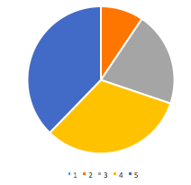 _____________________________

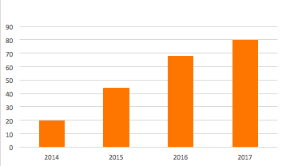 ____________________________

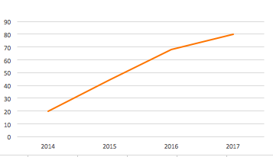 _____________________________

Task 2: Match the following phrases to describe the lines below:

*remain steady // fluctuate // slightly decrease // sharply decrease // sharply increase // go up a little*

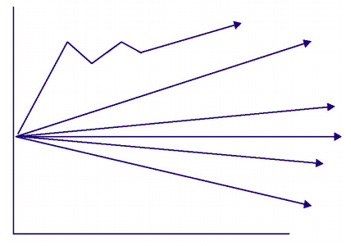

Task 3: Plot the amount of hours you get on average each week on to the graph below.

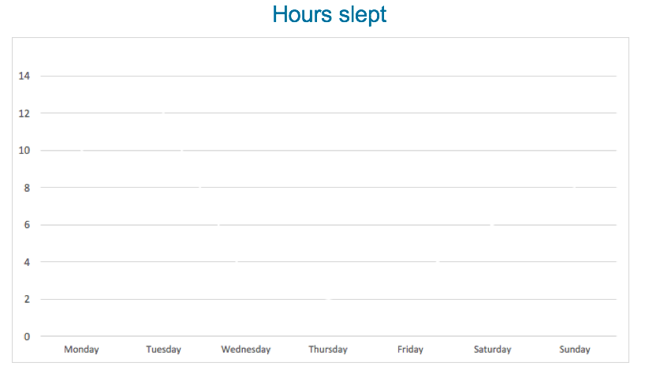

Task 4: Using the language in task 2 as a guide, describe your graph in 150 words.